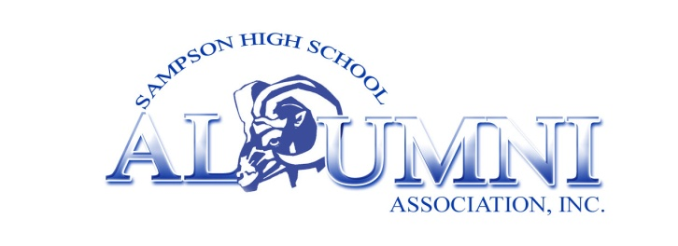
3340 Fordington Place Waldorf, MD 20603
Executive Board, 2013 – 2015  Faye Faison, President  Freddie Lee, Vice President  Stacy Allen, Business Manager  Reginald Chestnutt, Treasurer  Larry W. Elmore, Financial Secretary  Patricia McCalop, Recording Secretary  Jacinta Handon, Corresponding Secretary  Leeomina Byam, Parliamentarian/Sgt-At-Arms  National Chapters & Presidents  Atlanta: Reginald Chestnutt  Baltimore: Freddie Lee  Clinton: T. Pamela Bennett  Connecticut: Lortrine B. Shabazz  Fayetteville: Robert Bennett  Golden States: Rev. Floyd Howard  Raleigh: Beverly J. Marriott  Southern New Jersey: Brenda Fraction  Washington Metro: Larry W. Elmore |  | As you make your contribution please fill out the lower portion of this page and return along with your check made payable to:  SHSAA, Inc. Endowment Program  And  Mail to: Larry W. Elmore  Financial Secretary, SHSAA, Inc.  P.O. Box 975  Riverdale, MD 20738-0975  We look forward to your commitment and support.  Sampson High School Alumni Association, Inc.  Scholarship Endowment Program  Name: __________________________________________________  Phone: __________________________________________________  Address: _________________________________________________  ________________________________________________________  Email: __________________________________________________
“We are only as strong as we are united, as weak as we are divided!!!”

